Docker Challenge-01

- Create a customized Docker image using a Dockerfile.
Create a custom Docker image using a Dockerfile.

Step 1:
Let’s create a small HTML file for demonstration:
Vi index.html

Step 2: Create a Dockerfile
Vi Dockerfile

Step 3: Build the Docker image
Run this command in the same directory as your Dockerfile:
docker build -t my-custom-nginx .
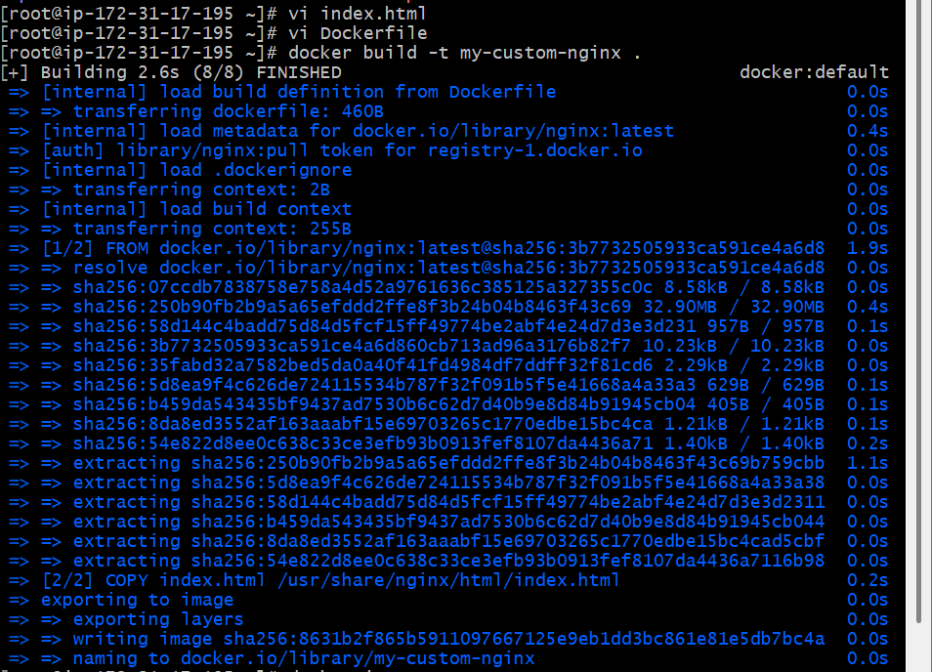

Step 4: Verify the image
docker images

Step 5: Run a container from the image
docker run -d -p 8080:80 my-custom-nginx

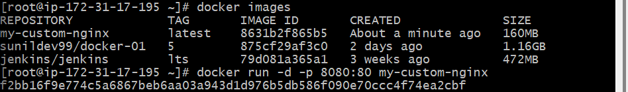

now, open your browser and visit:
http://localhost:8080
You should see your custom HTML page.
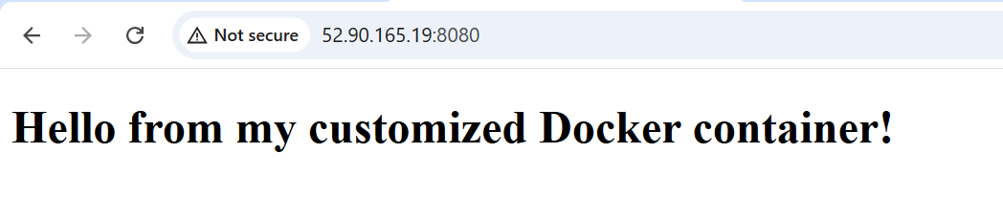
- Push the image to Docker Hub.

Pre-requisites
- You must have a Docker Hub account — if not, create one at https://hub.docker.com.
- Make sure you are logged into Docker Hub using the Docker CLI.

Step 1: Login to Docker Hub
docker login
You’ll be prompted to enter your Docker Hub username and password.
✅ Example output:
Login Succeeded
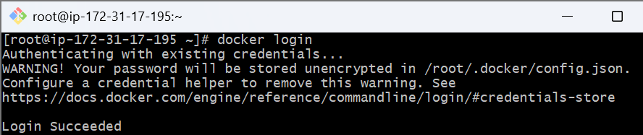

Step 2: Tag your image
Docker images must be tagged with your Docker Hub username and repository name before pushing.
If your username is sunil123, and your image name is my-custom-nginx, tag it like this:
docker tag my-custom-nginx sunil123/my-custom-nginx:latest
Explanation:
- my-custom-nginx → existing local image name
- sunil123/my-custom-nginx:latest → new name with your Docker Hub username and tag

Step 3: Verify the tagged image
docker images

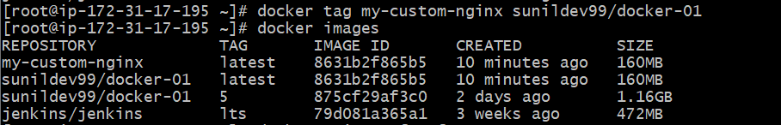

Step 4: Push the image to Docker Hub
docker push sunil123/my-custom-nginx:latest
Docker will upload all the layers to your repository.
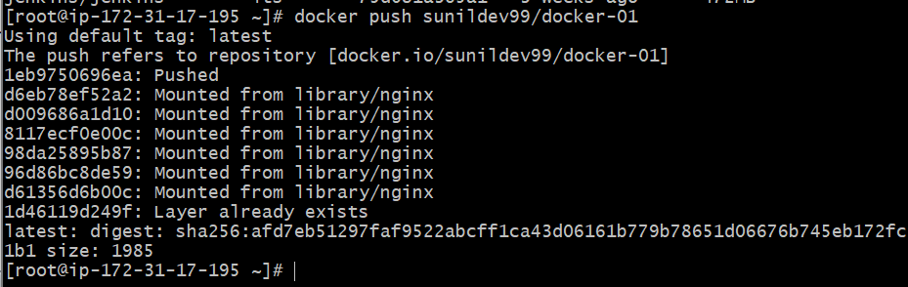

Step 5: Verify on Docker Hub
Go to your Docker Hub profile → Repositories
You’ll see your new repo my-custom-nginx there with tag latest.
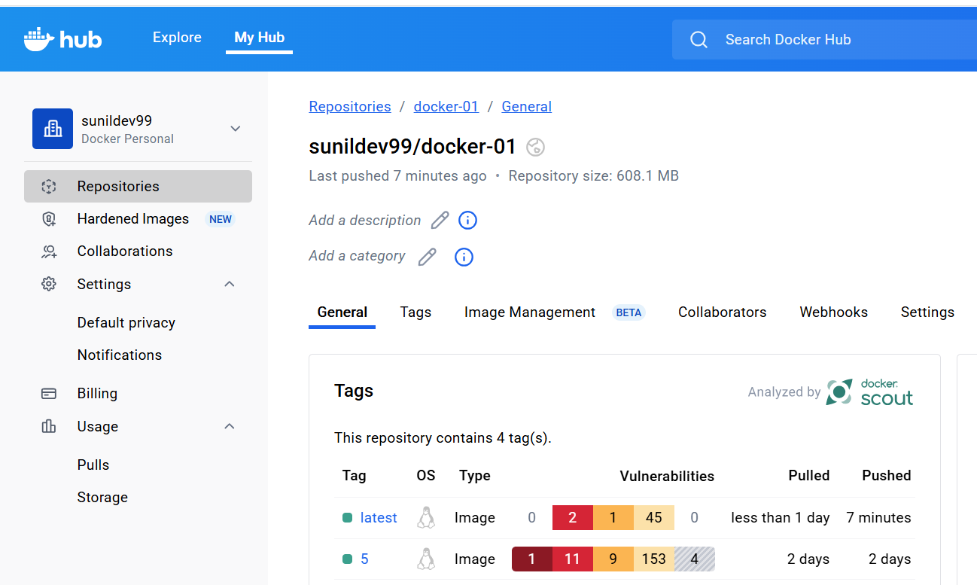
- Push the same image to Amazon ECR.

Pre-requisites
You must have:
- AWS CLI installed and configured (aws configure)

Step 1: Create a repository in ECR
You can do this either via AWS Console or CLI.

Using AWS CLI:
aws ecr create-repository --repository-name my-custom-nginx

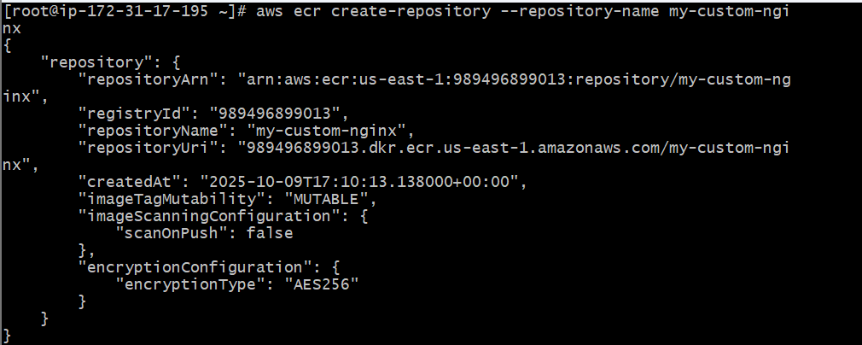

Step 2: Authenticate Docker to ECR
Run this command
aws ecr get-login-password --region us-east-1 | docker login --username A--password-stdin 989496899013.dkr.ecr.us-east-1.amazonaws.com

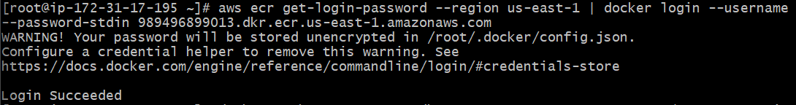

Step 3: Tag your local image
Tag your image with the full ECR repository URI.
docker tag my-custom-nginx 989496899013.dkr.ecr.us-east-1.amazonaws.com/mustom-nginx
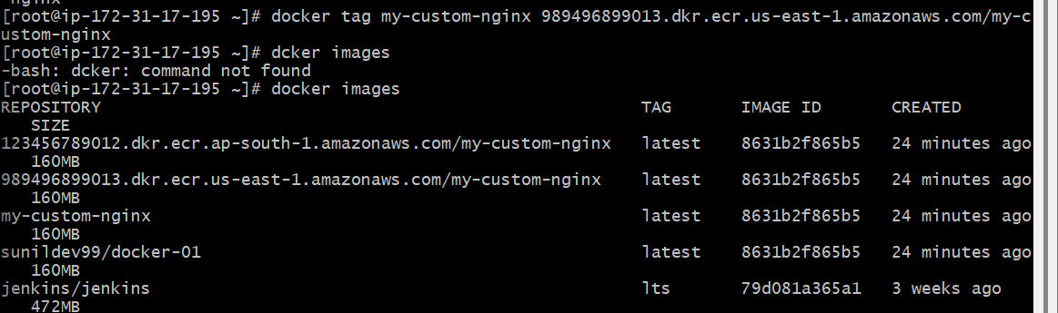
Step 4: Push the image to ECR
docker push 989496899013.dkr.ecr.us-east-1.amazonaws.com/my-custom-nginx Using default tag: latest
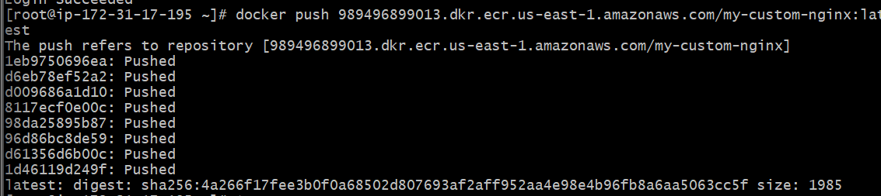

Verify in AWS Console
- Go to AWS Management Console → ECR → Repositories
- Open my-custom-nginx
- You’ll see the pushed image under the Images tab.
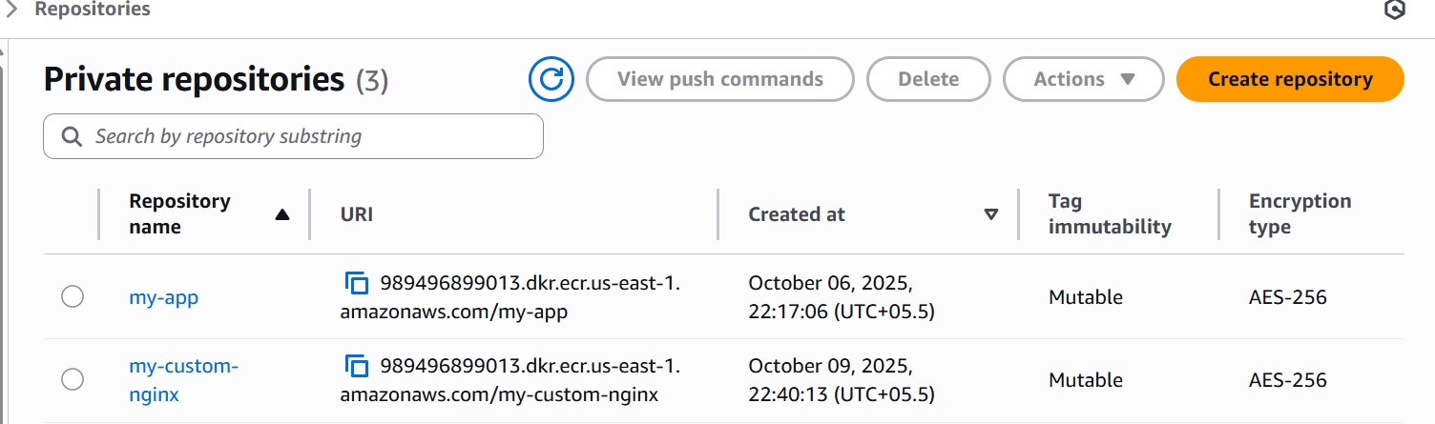

- Provision one EC2 instance using Terraform and install Jenkins.

Step 1: (create main.tf)
main.tf

resource "aws_instance" "jenkins" {
ami = "ami-0886832e6b5c3b9e2" # Amazon Linux 2 (us-east-1)
instance_type = "t2.micro"
key_name = "kube"

user_data = <<-EOF
#!/bin/bash
# Update system packages
yum update -y

# Install Java 17 (Amazon Corretto) - recommended for Jenkins
yum install -y java-17-amazon-corretto git wget

# Verify Java version
java -version

# Add Jenkins repository
wget -O /etc/yum.repos.d/jenkins.repo https://pkg.jenkins.io/redhat-stable/jenkins.repo
rpm --import https://pkg.jenkins.io/redhat-stable/jenkins.io-2023.key

# Install Jenkins
yum install -y jenkins

# Ensure Jenkins uses correct Java binary
sed -i 's|^JENKINS_JAVA_CMD=.*|JENKINS_JAVA_CMD="/usr/bin/java"|' /etc/sysconfig/jenkins

# Enable and start Jenkins service
systemctl daemon-reexec
systemctl daemon-reload
systemctl enable jenkins
systemctl start jenkins
EOF

tags = {
Name = "Jenkins-Server"
}
}

Initialize and Apply Terraform
Run these commands:
terraform init
terraform plan
terraform apply
Terraform will:
- Launch an EC2 instance
- Install Jenkins via user_data

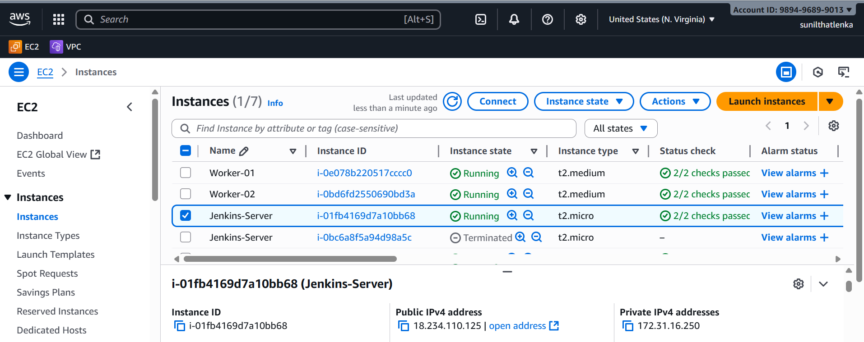
Then to get the initial Jenkins password:
ssh -i ~/.ssh/id_rsa ec2-user@<public-ip>
sudo cat /var/lib/jenkins/secrets/initialAdminPassword

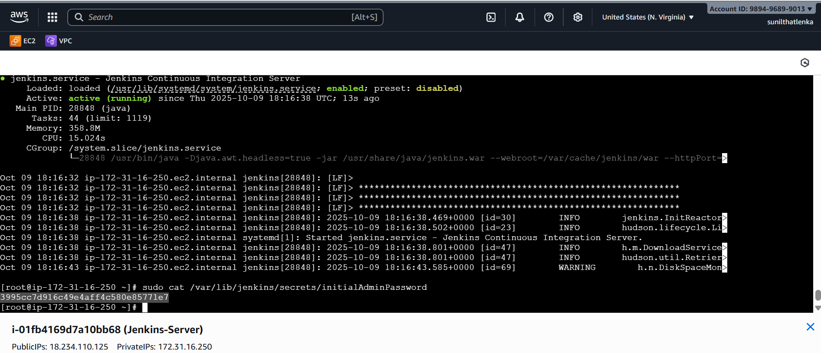

Access Jenkins
Once complete, Terraform outputs the public IP.
Open this in your browser:
http://<public-ip>:8080

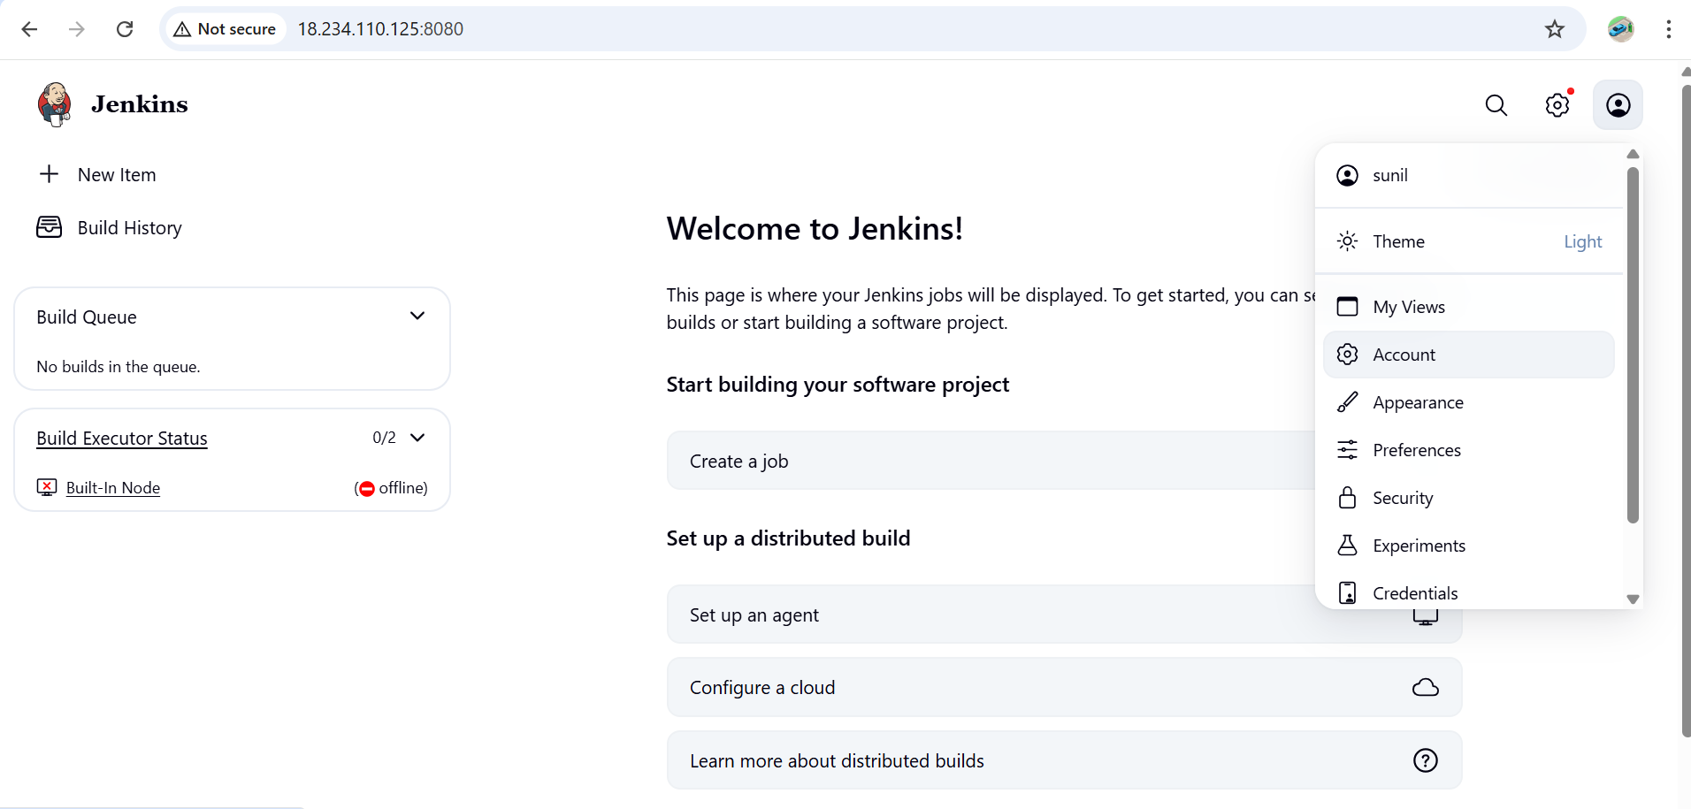
- Create one Jenkins job to build and push the Docker image to Docker Hub.
  - Source: https://github.com/betawins/Python-app.git

Step 1: Add Docker Hub Credentials in Jenkins
- Go to Jenkins Dashboard → Manage Jenkins → Credentials → Global → Add Credentials
- Choose:
  - Kind: Username with password
  - Username: <your-dockerhub-username>
  - Password: <your-dockerhub-password or token>
  - ID: dockerhub (you’ll reference this ID in your pipeline)

Step 2: Create a New Pipeline Job
- Go to Jenkins Dashboard → New Item
- Name it: docker-pipeline
3. Select Pipeline, then click OK
Step 3: Configure the Pipeline
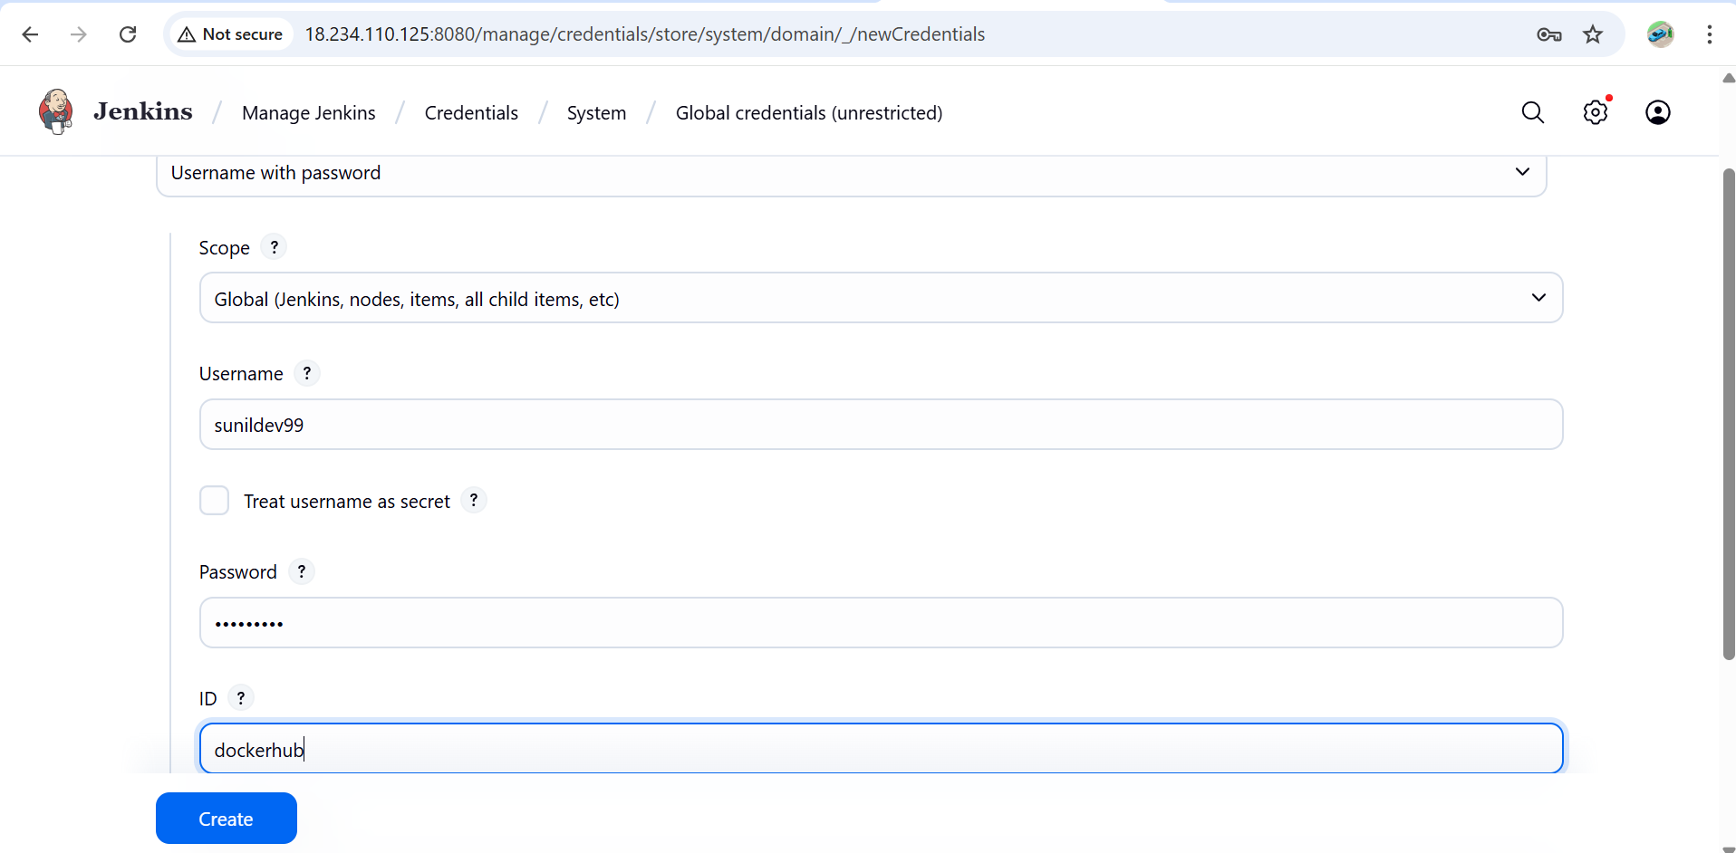

Step 5: Save and Build
- Click Save
- Then click Build Now
✅ Jenkins will:
- Clone the GitHub repo
- Build a Docker image from the Dockerfile
- Log in to Docker Hub
- Push the image (latest tag)
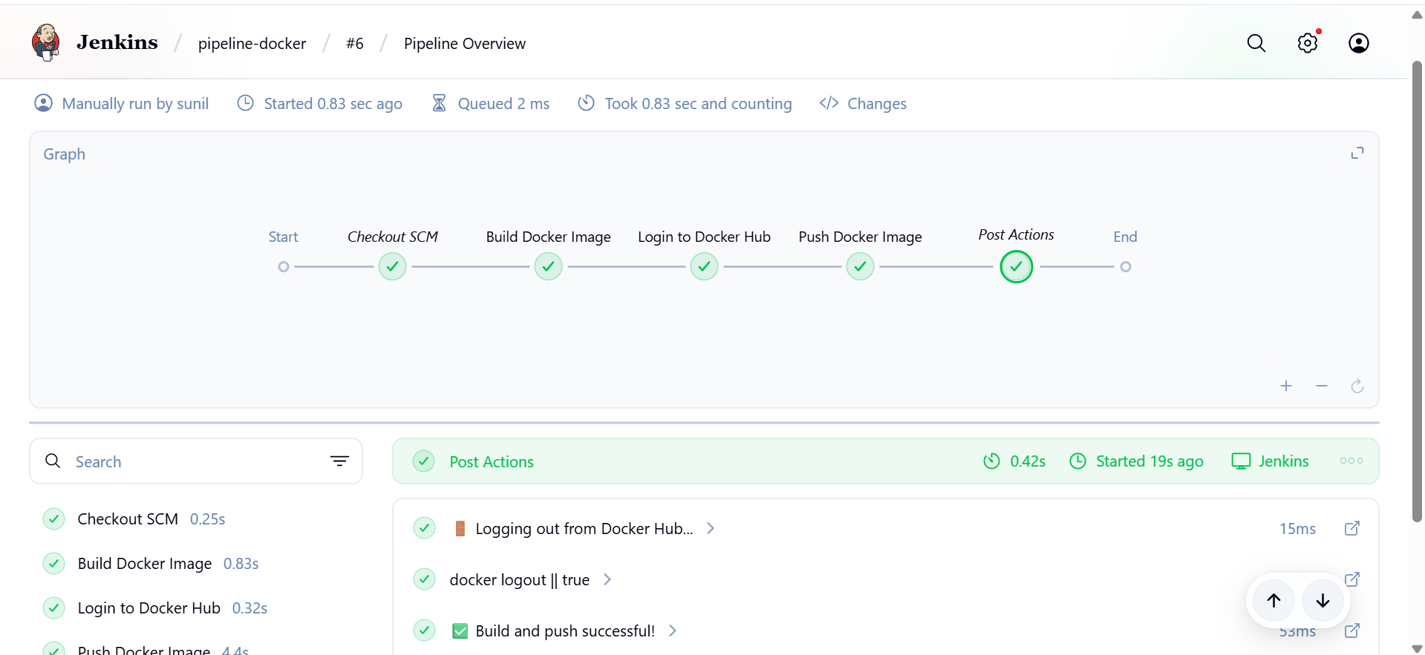

Check the docker hub
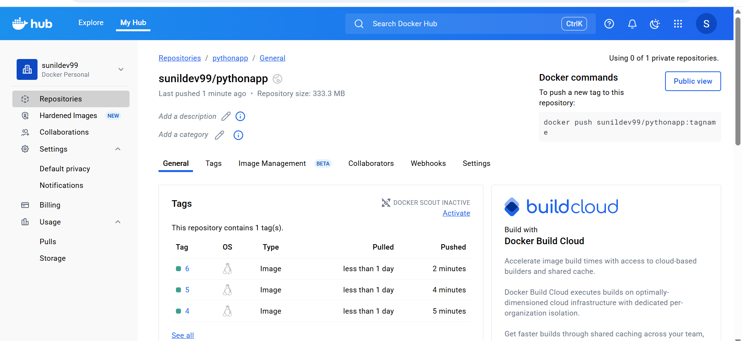
pull the image from docker hub to local and run
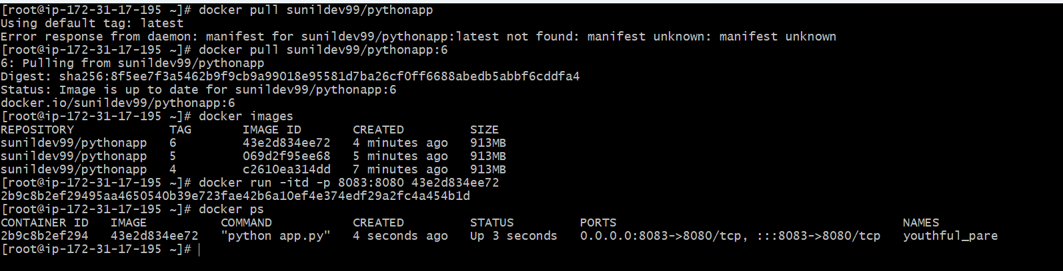
Verify in web
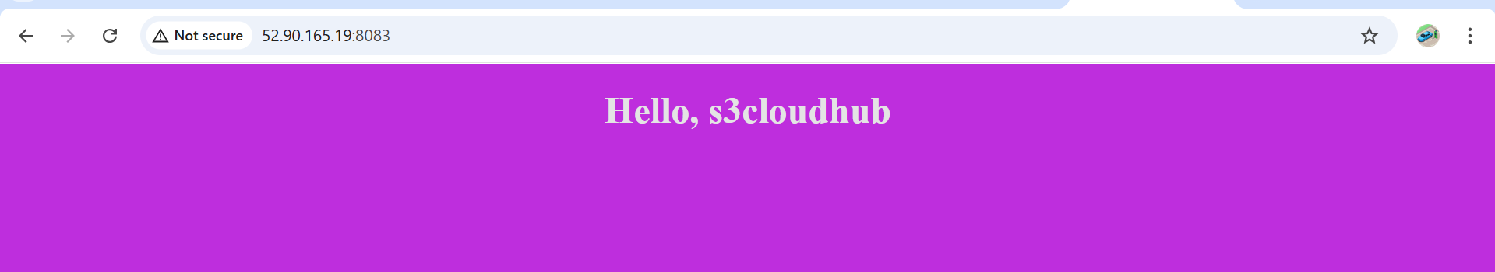

 Source Codes: https://github.com/betawins/docker-tasks.git
- From the frontend source code, write a Dockerfile, build a Docker image, run it, and push that image to your Docker registry.
Step -1 First fork the repo or and clone the git repo
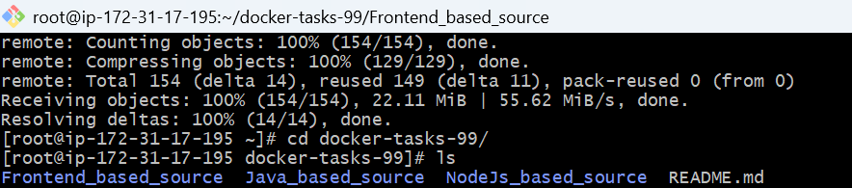
Goto fronted and create a dockerfile
Vi Dockerfile
# Use lightweight Nginx image
FROM nginx:alpine
WORKDIR /usr/share/nginx/htm
l# Remove default Nginx content
RUN rm -rf ./*
# Copy frontend project files
COPY . .
EXPOSE 80
CMD ["nginx", "-g", "daemon off;"]

Build the Docker image locally
docker build -t frontend .
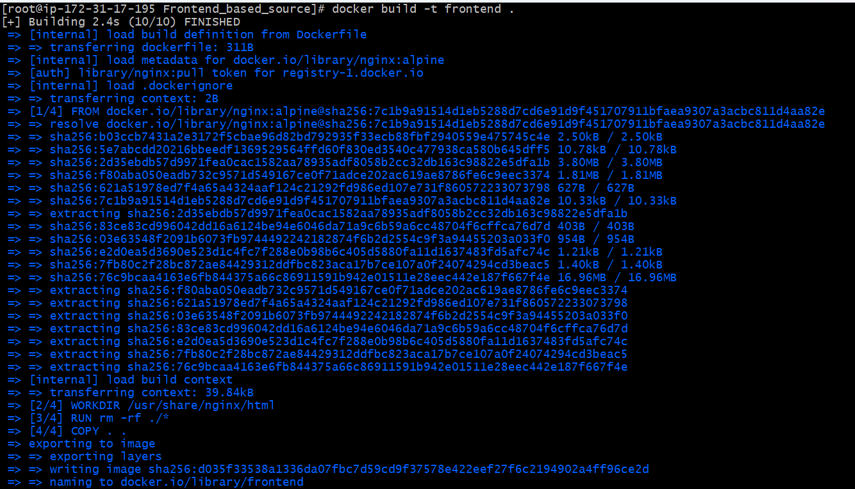
check the images
docker images
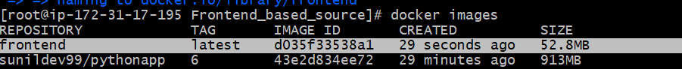
- Run the built image locally and check whether the container is running or not:

Now open in browser: http://publicip :80 and you should see your frontend.


Docker tag your image
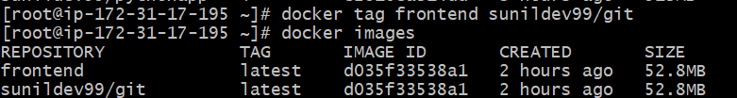

- Push the image to Docker registry (Docker Hub or other):
--> login: docker login
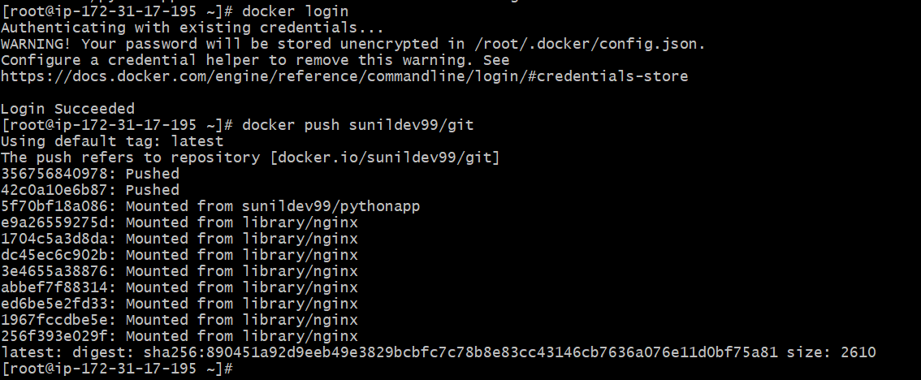
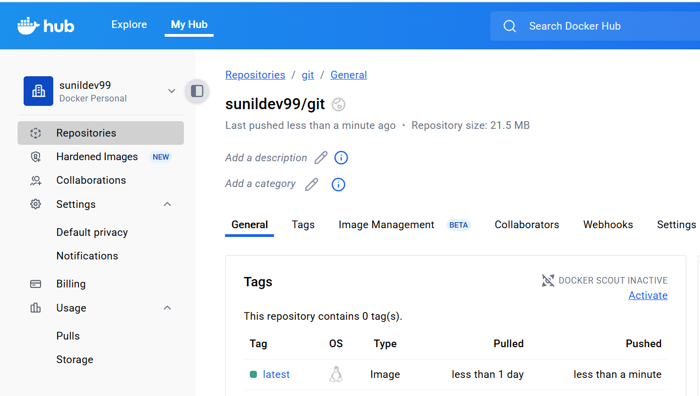

- From the Java-based source code, write a Dockerfile, build, run, and push the image to the Docker registry.
Create a dockerfile and build a image

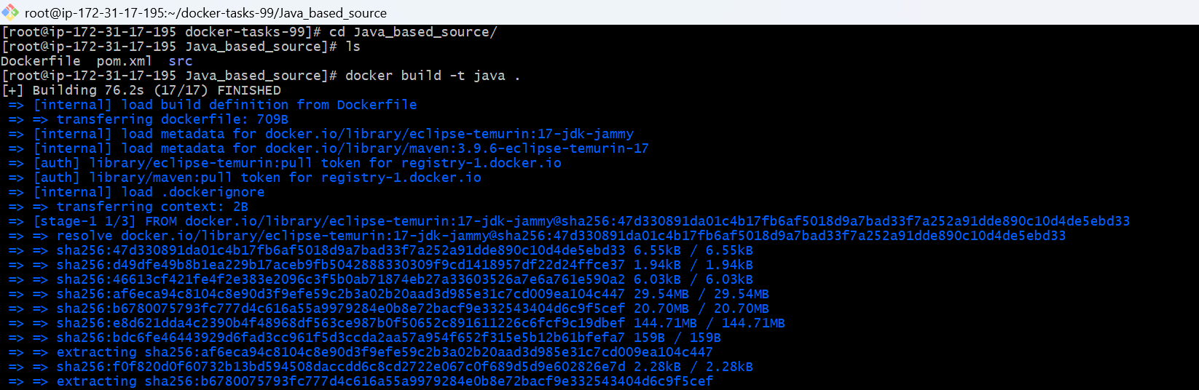
check the docker images
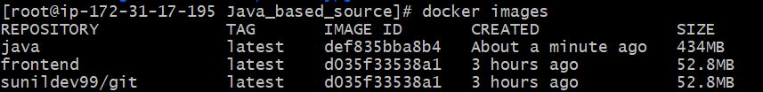
run the container
Verify in the web with public ip and the port no.
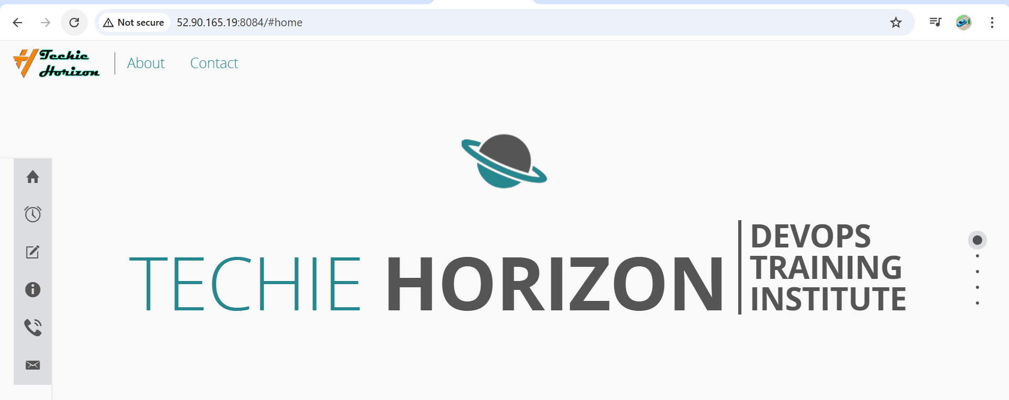
Docker tag and push the image to the docker registry
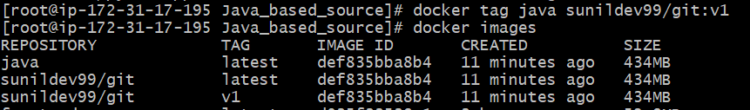
Docker push
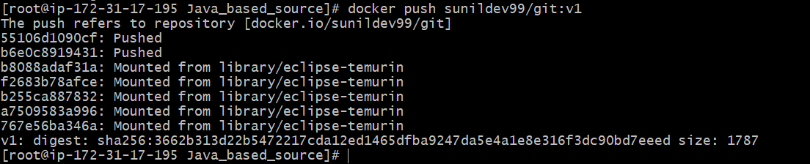
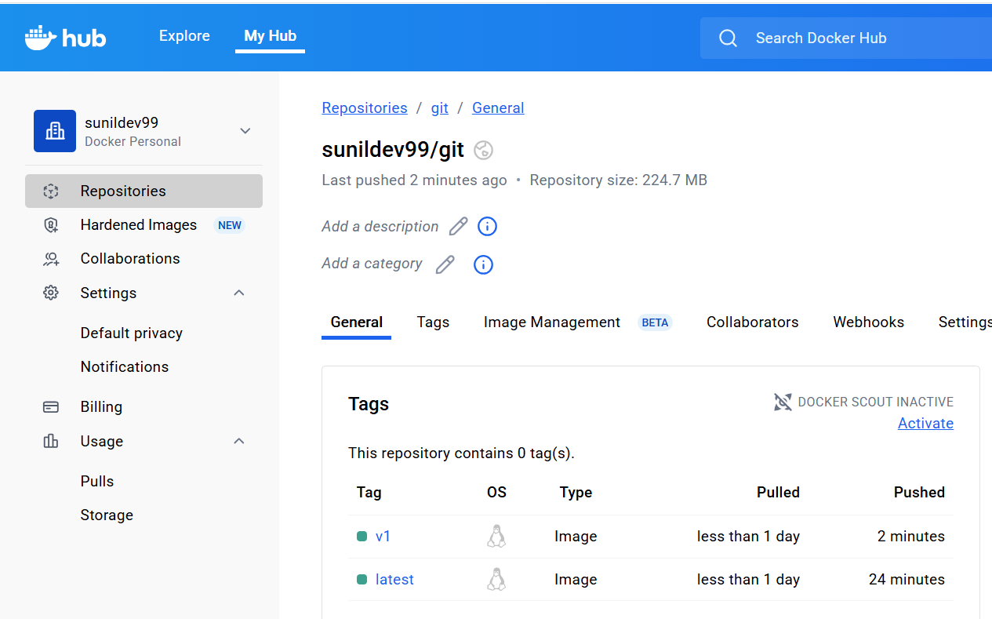
- From the Node.js-based source code, write a Dockerfile, build with tag v1, run, and push it to the Docker registry.
Create a dockerfile and build a image
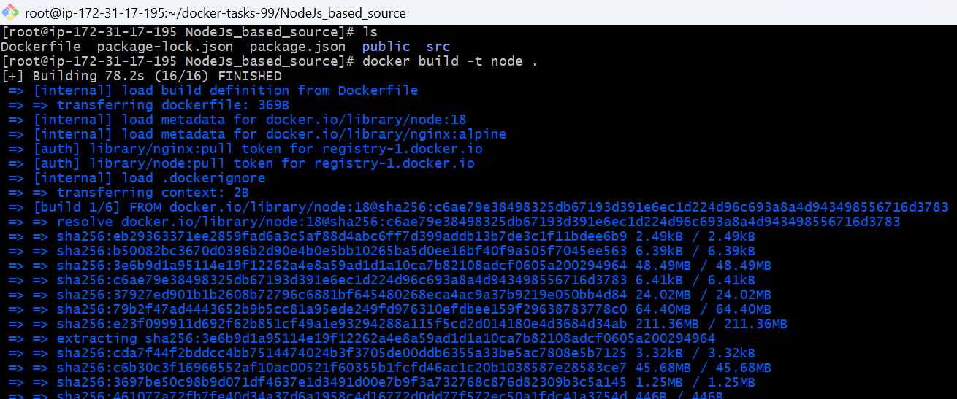
Docker images
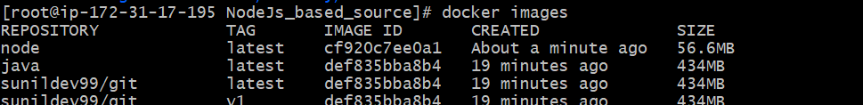
Docker run
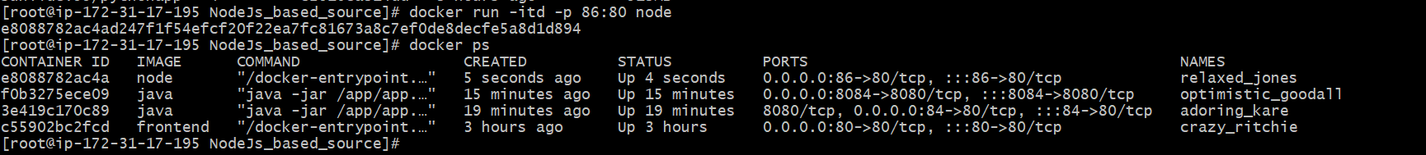
Verify in the web with port no.

Docker tag the image and push
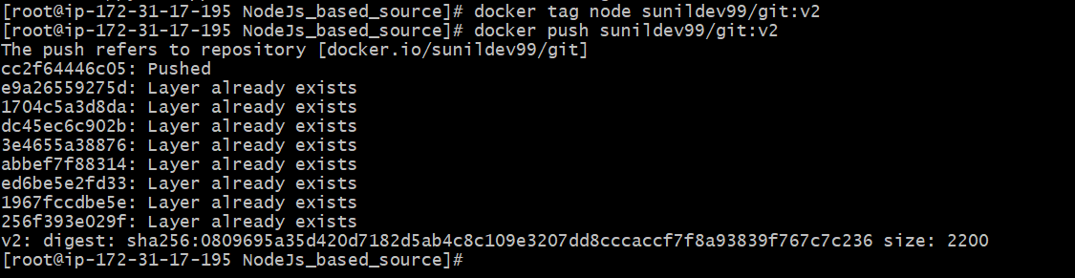
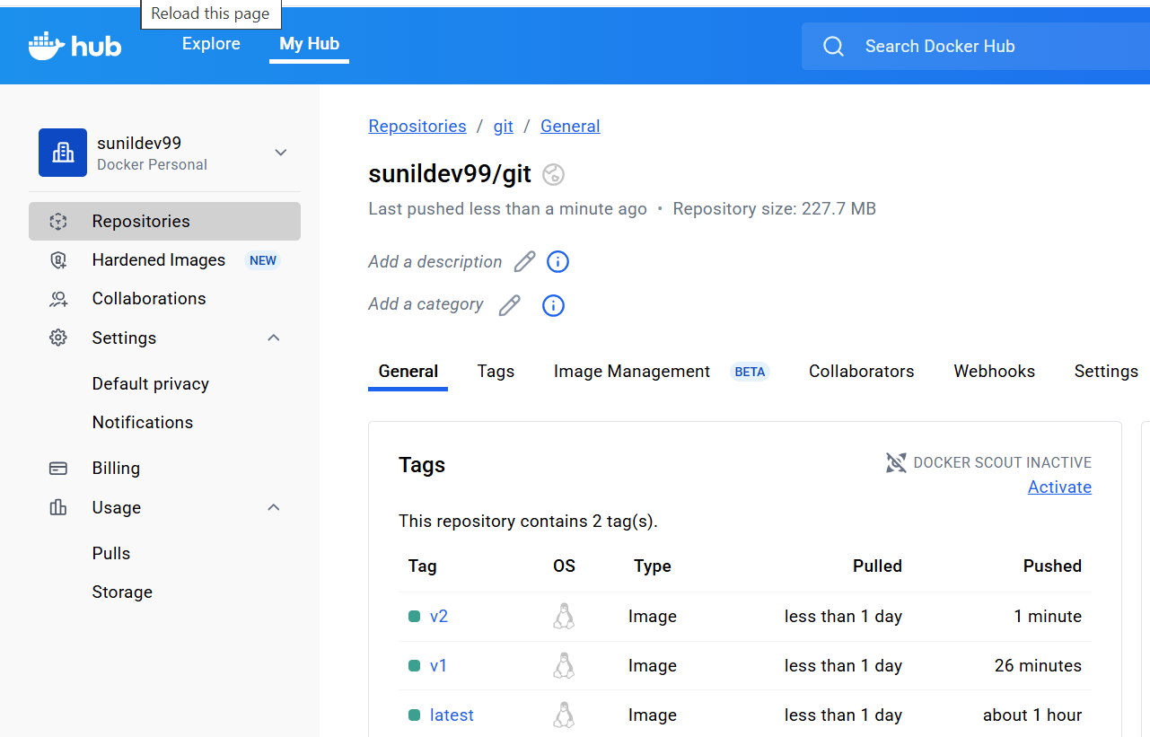
Write a docker-compose file to set up WordPress with a MySQL database

# Stop all containers (optional but safe)
docker stop $(docker ps -aq)
# Remove all stopped containers
docker container prune -f
# Remove all unused images
docker image prune -a -f
# Remove unused volumes
docker volume prune -f
# Remove unused networks
docker network prune -f
# Full cleanup (everything unused)
docker system prune -a -f --volumes

Docker Compose v2 (plugin)
Run these commands step by step:
# 1 Create the plugin directory
sudo mkdir -p /usr/local/lib/docker/cli-plugins

# 2 Download the latest Docker Compose binary
sudo curl -SL https://github.com/docker/compose/releases/latest/download/docker-compose-linux-x86_64 \
-o /usr/local/lib/docker/cli-plugins/docker-compose

# 3 Give execute permission
sudo chmod +x /usr/local/lib/docker/cli-plugins/docker-compose

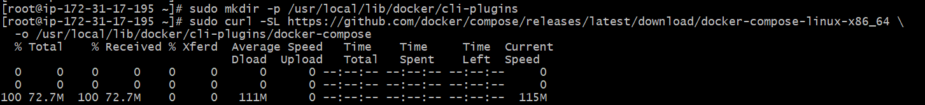
# 4 Verify installation
docker compose version

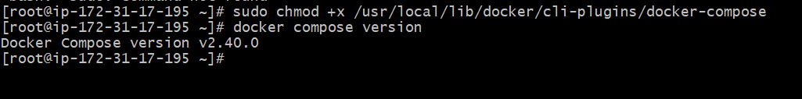
Step 1: Create a Project Directory:
mkdir wordpress-docker
cd wordpress-docker
Step 2: Create docker-compose.yml
Vi docker-compose.yml
Step 3: Start the Containers:
docker-compose up –d
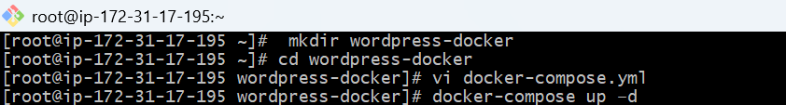
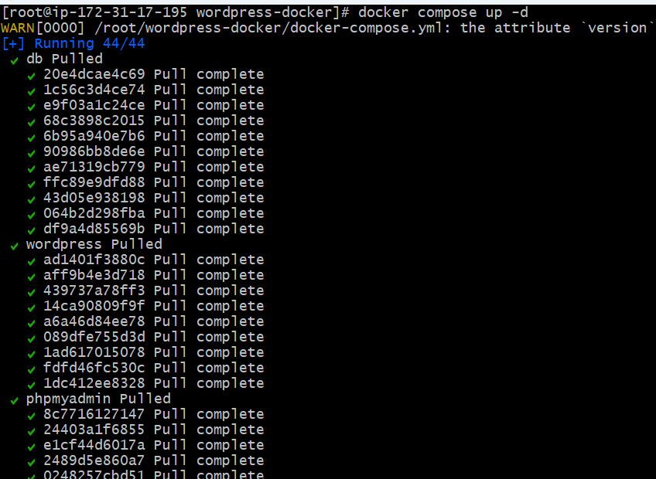docker image
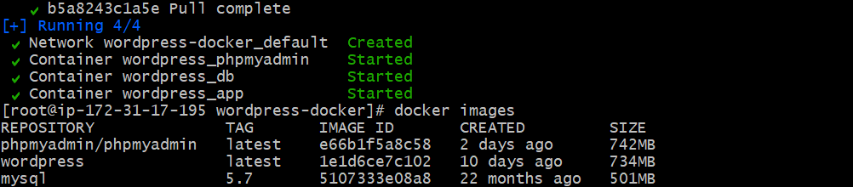
Docker ps
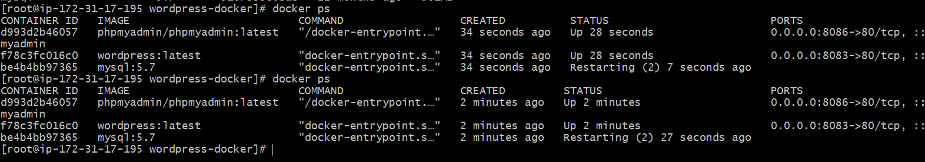
Then access:
- WordPress → http://<EC2-IP>:8083
- phpMyAdmin → http://<EC2-IP>:8086
Login to phpMyAdmin with:
Username: root
Password: rootpassword

- 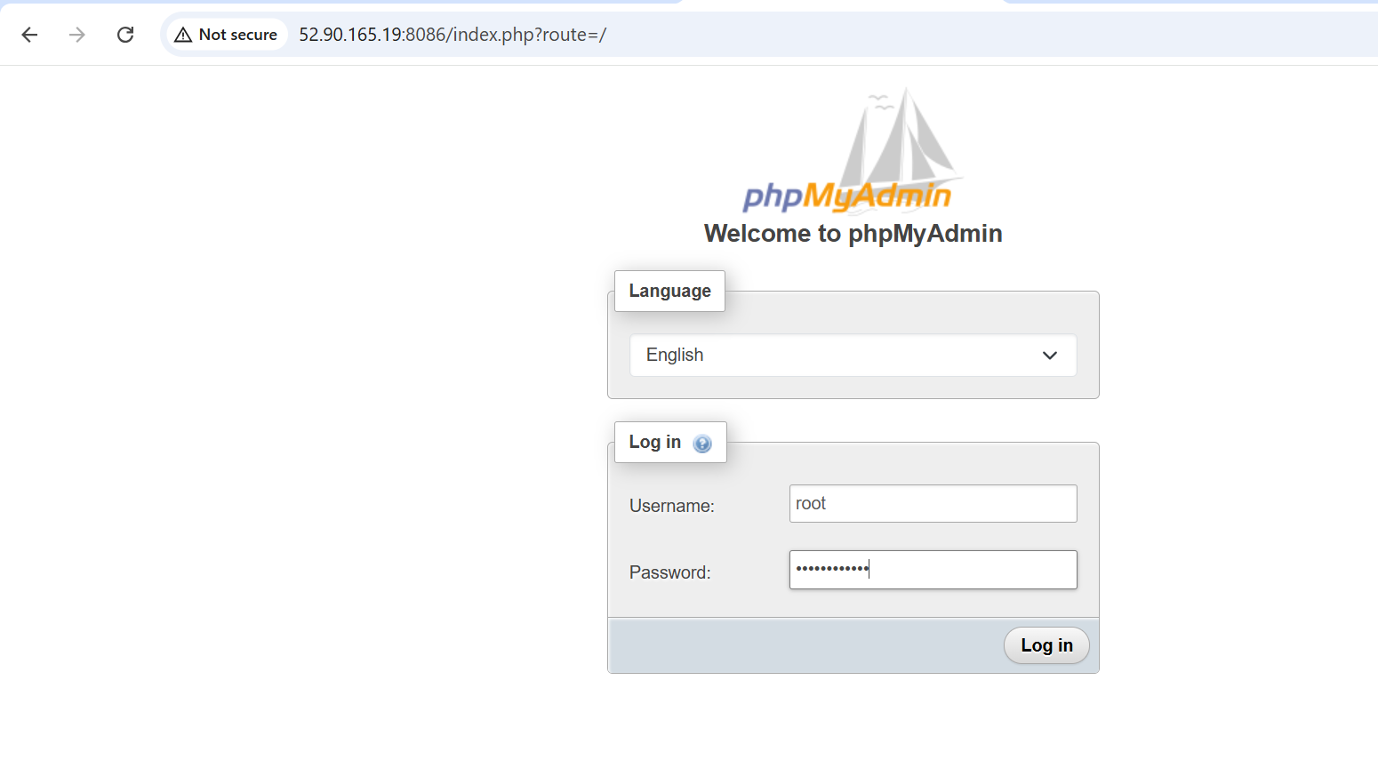 WordPress → http://<EC2-IP>:8083
- Complete the setup wizard:
a. Site title: My Test Site
b. Username: wpuser
c. Password: wppassword
d. Email: sunil@gmail.com
•Login at

